BLT Southern Bluefin tuna Thunnus maccoyii
Juvenile:
The diet of juvenile (predominantly age 1) southern bluefin tuna Thunnus maccoyii. off southern Western Australia during summer, consisted overwhelmingly of teleosts (97.4% by volume). Pilchard Sardinops sagax (27.4%V), blue mackerel Scomber australasicus (16.7%V), and jack mackerel Trachurus declivis (14.2%V) were the major taxa, with pilchard more abundant in coastal waters and jack mackerel more frequently encountered in fish caught closer to the shelf-edge. Prey size varied from 5 to 240 mm, with 67% of ingested items measuring between 30 and 50 mm. Pilchard dominated the prey size category 130–190 mm (84% by number), but the overall contribution of this species to the diet of juvenile
SBT was much lower than previously reported.
Prey taxa were encountered in 636 out of 720 stomachs and consisted overwhelmingly of teleosts (92.8%N, 97.4%V), with crustaceans (6.5%N, 0.5%V) and cephalopods (0.7%N, 2.1%V) constituting a very small proportion of the diet of juvenile SBT. At a lower taxonomic level, the major prey taxa (%V[5%) were represented by: Clupeidae (18.1%N, 22.2%O, 31.4%V) including pilchard Sardinops sagax (9.9%N, 18.1%O, 27.4%V) and anchovy Engraulis australis (8.4%N, 10.6%O, 8.2%V), Scombridae as represented by blue mackerel Scomber australasicus (21.5%N, 30.0%O, 16.7%V), and Carangidae as represented
by jack mackerel Trachurus declivis (3.7%N, 13.3%O, 14.2%V). The results suggested a difference in prey composition between the area within 20 km from the shelf-edge and the coastal area further inshore (Fig. 3). In general terms, it appeared that the main occurrence of
pilchard was in coastal waters while that of jack mackerel was closer to the shelf-edge. Blue mackerel was encountered in both areas, but perhaps more prevalent further offshore.
The total body lengths of a total of 10,336 prey items (87% of all prey) from 1,098 prey groups were recorded. Prey length varied in size from 5 to 240 mm, ranging from 30 to 50 mm for 67% of all ingested individuals (Fig. 4). Among 30 taxa found in stomachs, 30 were present in the\70 mm category. Only 11 taxa, including a few key species such as pilchard,
anchovy, blue mackerel, and jack mackerel, were additionally present in size categories [70 mm. Importantly, pilchard formed 84% of prey individuals ranging in length from 130 to 190 mm. The prey size range varied widely in relation to SBT fork length and was notably broad for SBT between 45 and 60 cm fork length.
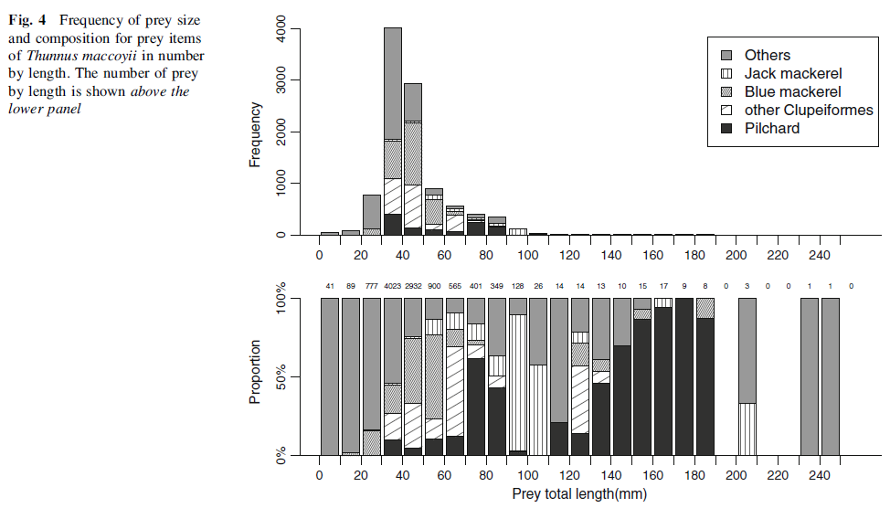

adults
Prey from the families Carangidae (particularly Trachurus declivis), Scombridae (including Katsuwonus pelamis) and Ommastrephidae (particularly Ommastrephes bartramii and Nototodarus sloanii) were the dominant prey families

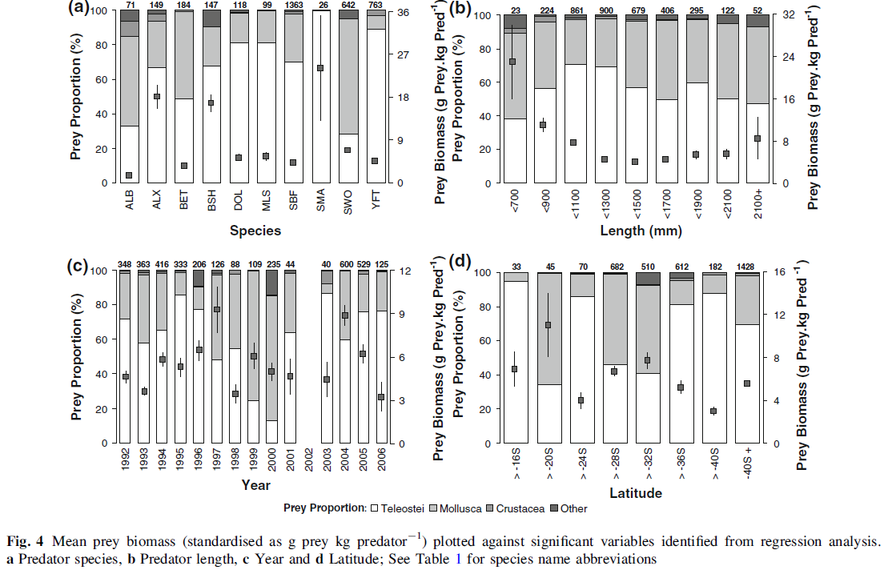
Fig. 5 Relative proportions of prey families contributing[1% wet weight to prey biomass for fish predators off eastern Australia. ALX Lancetfish, DOL Dolphinfish, SMA Mako shark,
YFT Yellowfin tuna, MLS Striped marlin, SBF Southern bluefin tuna, BET Bigeye tuna, BSH Blue shark, ALB Albacore, SWO Swordfish.

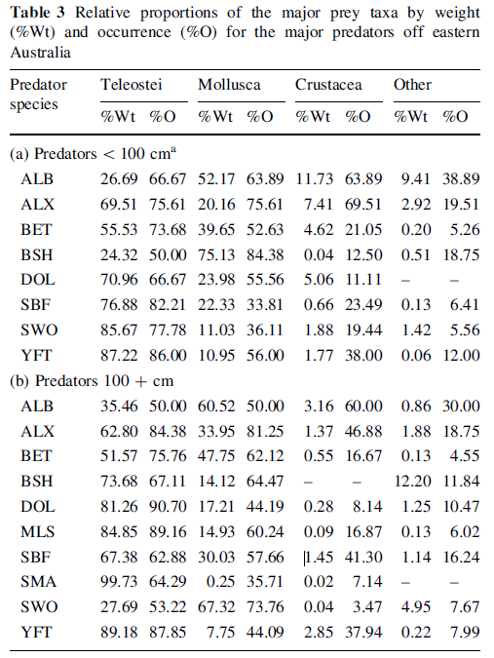

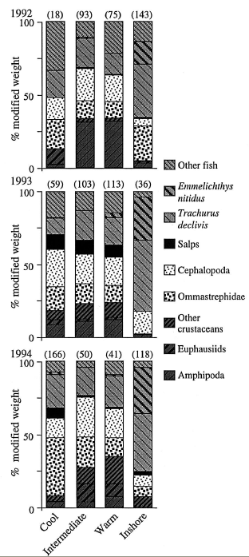
Inshore, fish were the main prey, mainly due to two species, jack mackerel Trachurus declivis and redbait Emmelichthys nitidus. Although crustaceans were next in order of frequency of occurrence, they contributed little in terms of biomass. Pelagic amphipods, not normally found over the shelf, were unexpectedly frequent. Tuna from the shelf with stomachs full of krill Nyctiphanes australis were reported to one of us (JWY) by local fishers,
but few of these samples were kept. Cephalopods – mainly of juvenile Nototodarus gouldi (mantle length 49.05 mm ± 1.35 SE), were the second most important prey taxon in inshore-caught tuna. Offshore, Crustacea (mainly Phronima sedentaria) were the most common prey taxon by frequency of occurrence, but contributed little to overall biomass. A diverse mix of cephalopod species, but mainly Lycoteuthis lorigera and adult Nototodarus gouldi (mantle length 85.78 mm ± 2.56 SE), made up the largest component of the diet offshore. Next
in importance was a variety of fish species. That the largest component of this group was jack mackerel.
Relative proportions of the main prey taxa of southern bluefin tuna in relation to size of tuna from inshore and offshore waters of eastern Tasmania, Australia.

The diet of southern bluefin tuna consisted of a wide variety of prey taxa over a wide size range. In the inshore region, fish (Trachurus declivis and Emmelichthys nitidus) and juvenile squid Nototodarus gouldi were the main prey. Offshore, there was a greater diversity, with more macrozooplankton prey (notably Phronima sedentaria) than in inshore waters. In southern and eastern Australian coastal waters, southern bluefin tuna preyed predominantly
on jack mackerel Trachurus declivis, and pilchards Sardinops neopilchardus; Nototodarus gouldi was the most commonly eaten cephalopod, and Nyctiphanes australis the predominant crustacean (Serventy 1956). Southern bluefin tuna caught on longlines off northern New Zealand had eaten a variety of pelagic fish species, crustaceans (including amphipods,
euphausiids and penaeids), as well as squid and octopus (Robins 1963).
Inshore, tuna < 90 cm ate less 289 fish than the larger groups, indicating that their jack mackerel prey approached the maximum size that southern bluefin < 90 cm can eat. The presence of greater proportions of salps in the diet of the largest size class of inshore-caught tuna may indicate that these larger fish are feeding closer to the edge of the continental shelf than the smaller fish. Amongst the offshore fish, only the largest size class showed no significant diet overlap with the other sizes. The diet of these large fish contained fewer Trachurus declivis and larger proportions of other fish and salps. One explanation may be that they are feeding further out to sea than the smaller fish, away from the shelf and shelf break where T. declivis is most abundant.

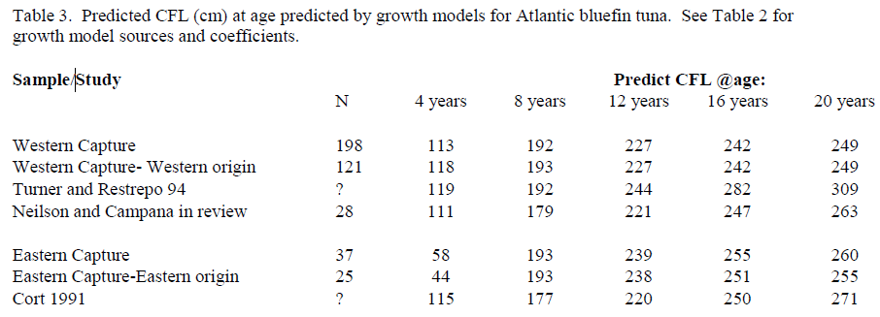

GROWTH OF ATLANTIC BLUEFIN TUNA: DIRECT AGE ESTIMATES D. H. Secor1, R.L. Wingate1, J.D. Neilson2, J.R. Rooker3, and S.E. Campana4
SCRS/2008/084
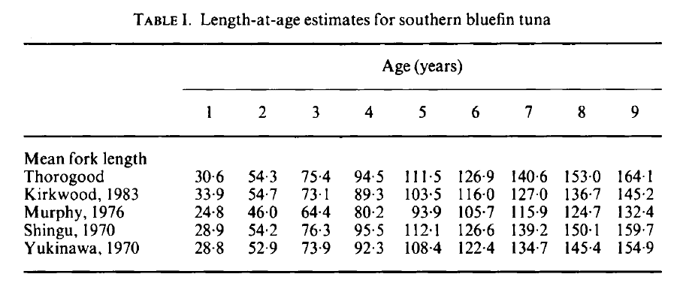
Southern Bluefin Tuna 700 mm 3 years
prey item | probability of consuming
SAR | 0.3
FPK | 0.3
CEP | 0.01
ZKL | 0.01
PRW | 0.01
ZME | 0.01
SAL | 0.01

Southern Bluefin Tuna 900 mm 4 years
prey item | probability of consuming
SAR | 0.3
FPK | 0.3
CEP | 0.01
ZKL | 0.01
PRW | 0.01
ZME | 0.01
SAL | 0.01

Southern Bluefin Tuna 1100 mm 5 years
prey item | probability of consuming
SAR | 0.3
FPK | 0.3
CEP | 0.01
ZKL | 0.01
PRW | 0.01
ZME | 0.01
SAL | 0.01
Southern Bluefin Tuna 1300 mm 7 years
prey item | probability of consuming
SAR | 0.3
FPK | 0.3
CEP | 0.01
ZKL | 0.01
PRW | 0.01
ZME | 0.01
SAL | 0.01

Southern Bluefin Tuna 1500 mm 8 years
prey item | probability of consuming
SAR | 0.3
FPK | 0.3
CEP | 0.01
ZKL | 0.01
PRW | 0.01
ZME | 0.01
SAL | 0.01

Southern Bluefin Tuna 1700 mm 10 years
prey item | probability of consuming
SAR | 0.3
FPK | 0.3
CEP | 0.01
ZKL | 0.01
PRW | 0.01
ZME | 0.01
SAL | 0.01
Southern Bluefin Tuna 1900 mm
prey item | probability of consuming
SAR | 0.3
FPK | 0.3
CEP | 0.01
ZKL | 0.01
PRW | 0.01
ZME | 0.01
SAL | 0.01

Southern Bluefin Tuna 2100 mm 12 years
prey item | probability of consuming
SAR | 0.3
FPK | 0.3
CEP | 0.01
ZKL | 0.01
PRW | 0.01
ZME | 0.01
SAL | 0.01

Southern Bluefin Tuna +2100 mm 14+ years
prey item | probability of consuming
SAR | 0.3
FPK | 0.3
CEP | 0.01
ZKL | 0.01
PRW | 0.01
ZME | 0.01
SAL | 0.01

Southern Bluefin Tuna
90 - >170 cm same diet

Reference
Tomoyuki Itoh • Hans Kemps • John Totterdell 2011. Diet of young southern bluefin tuna Thunnus maccoyii in the southwestern coastal waters of Australia in summer. Fish Sci (2011) 77:337–344

Jock W. Young • Matt J. Lansdell • Robert A. Campbell • Scott P. Cooper • Francis Juanes • Michaela A. Guest Feeding ecology and niche segregation in oceanic top predators off eastern Australia. Mar Biol (2010) 157:2347–2368

